**Title of Your Paper, Capitalize First Letter**

(*Bahnschrift, 14, space 1*)

**Name, Surname1, Name, Surname2,** (*Bahnschrift, 11, space 1*)

1Affiliation (*Bahnschrift, 11, space 1*)

2Affiliation (*Bahnschrift, 11, space 1*)

Email Author: (*Bahnschrift, 12, space 1*, *spacing after 2*).

Received: XX Month XXXX; Accepted XX Month XXXX; Published XX Month XXXX

Ed 20XX; X(X): X-X

**Abstract**

(*Bahnschrift, 11, space 1)*

*The abstract should be in one paragraph. The font is Bahnschrift, 11 pt, and justify. Abstract is in 200-250 words, which is followed by 3-5 keywords. The abstract should succinctly describes your entire paper. It comprises of the purposes of the research, method, and the findings of the research from the researchers perspective and it is advised that researchers refrain from citing the works of others when writing abstracts. The section is like giving a researcher 15 seconds to give a narrative to readers for them to have a mental picture of the entire research s/he has conducted.*

**Keywords:** First keyword, second keyword, third keyword, forth keyword, fifth keyword

**Introduction** (*Bahnschrift, Bold 12, Spacing 1*)

Here introduce the paper, and put a nomenclature if necessary. The paragraphs continue from here and are only separated by headings, subheadings. Headers are bold and 12 pt. Insert an abstract of 3000 words, giving a brief account of the most relevant aspects of the paper.

References should be listed at the end of the paper in alphabetical order. Authors should ensure that every reference in the text appears in the list of references and vice versa. When the names are mentioned in the text, indicate reference citations as Pardilla and Henjilito (2020); Asilestari, Pardilla and Henjilito (2012). Authors should use APA style (see below).

Some examples of how your references should be listed are given at the end of this template in the ‘References’ section which will allow you to assemble your reference list according to the correct format and font size. For more than 3 authors the first 3 should be listed followed by “et al.”

**Methods** (*Bahnschrift, Bold 12, Spacing 1*)

Contains of methodology, material and procedure, assessment and data analysis. Methods should be reproducible, clear and written in detail. If standard procedure is used, it should have relevance reference. Materials and equipments that can affect the results of the experiment should be clearly described (producers/company and its specification), justified, first paragraph just to the right, single space.

**Results** (*Bahnschrift, Bold 12, Spacing 1*)

Written in a form of text, table and figure. The result is clearly presented, the data is adequately detail and explain the research question, states statistical significance of findings and no references are used.

1. Table

All tables should be numbered with Arabic numerals. Headings should be placed above tables, left justified. Leave one line space between the heading and the table. Only horizontal lines should be used within a table, to distinguish the column headings from the body of the table, and immediately above and below the table. Tables must be embedded into the text and not supplied separately. Below is an example which authors may find useful.

**Table 1.** An example of a table (Bahnschrift 11, spacing 1)

|  |  |  |  |  |  |  |  |  |  |
| --- | --- | --- | --- | --- | --- | --- | --- | --- | --- |
| **N** | **Test** | **Terms of registration** | **Experimental group (n = ?)** | | **Control group  (n = ?)** | | **Δx** | **t** | **p** |
| **X** | **s** | **X** | **s** |
|  | Test 1 | Until the experiment |  |  |  |  |  |  |  |
|  |  | After the experiment |  |  |  |  |  |  |  |
|  | Test 2 | Until the experiment |  |  |  |  |  |  |  |
|  |  | After the experiment |  |  |  |  |  |  |  |

1. Figure

Figure title are written below the figure/graph and is begun with number.

**Example :**

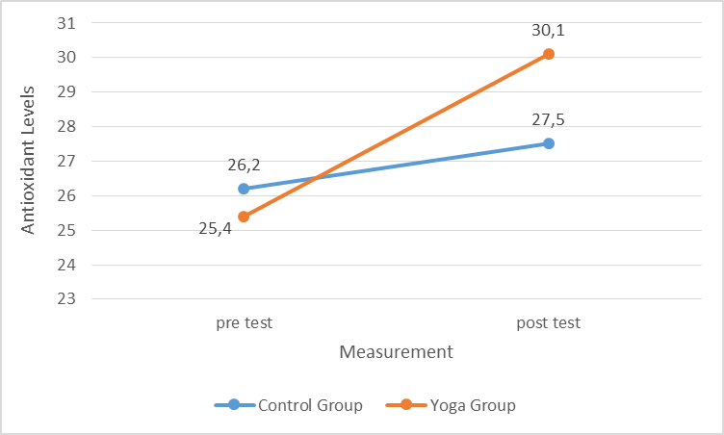

Figure 1. Antioxidant levels before and after intervention

**Discussion** (*Bahnschrift, Bold 12, Spacing 1*)

Discussion in the original research article consists of data interpretation (related to hypothesis/research objective), states comparison with relevance previous research (state of the art overview), outcome of the research through a critical analysis of the collected data, statement is clearly supported by data and linked to goals which reflect the result and follow a logical progression to its conclusion, research is clearly advanced in knowledge, research implications and limitations and statement about the generalization of research result.

Discusssion in literature review should be should be specific; current and of historical interesting; coherent and well organised around the research questions and key concepts; do not being summaries of literature; critical discussion of relevant information from different sources.

**Conclusions** (*Bahnschrift, Bold 12, Spacing 1*)

Conclusion in original research article should be written in a paragraph. It consists of conclusion of research data, research objective explanation, a probability to develop a new theory/concept based on fact/analysis, suggestion for further research based on the study of research weaknesses. Conclusion should not be in general, it consists of the conclusion of overall literature review, suggestion for further researcher and author’s perspective about the related topic.

**References** (*Bahnschrift, Bold 12, Spacing 1*)

All references referred to in the article text must be registered in the Bibliography section. Bibliography must contain reference libraries originating from primary sources (scientific journals and totaling at least 80% of the total bibliography) published in the last 10 (ten) years. Minimum number of bibliography sources 15. Writing Bibliography should use a reference management application such as Mendeley, EndNote, Zotero, or others. The writing format used in the Engineering journal is in accordance with the APA 6th Edition (American Psychological Association) format. Written in a single space (or at least 12pt), between libraries given a space of 1 space. Some examples of how to write references / references in the Bibliography, are given below.

Text Book

Bompa, T. O, & Buzzichelli, C. (2014). *Periodization Training for Sports-3rd Edition* (Third Edition). United States Of America: Human Kinetics.

Journal

Permadi, J., & Syam, A. R. (2016). Penerapan model pembelajaran kooperatif tipe Student Teams Achievement Division (STAD) terhadap hasil belajar dribble bola basket. *Jurnal Pendidikan Olahraga Dan Kesehatan*, 1(1), 13–23.